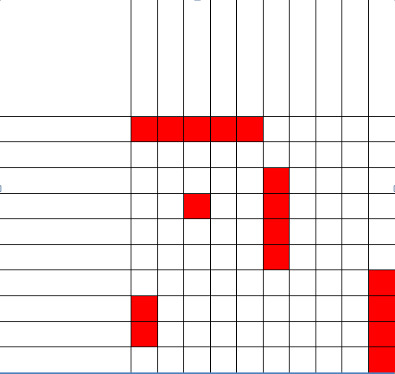I:\ECE21 Policy Legislation and Communication\Design Elements\GNWT Visual Identity Program 2016 updated\Wordmarks\GNWT Wordmarks\png\GNWT Wordmark ENG FL_REV.pngI:\ECE21 Policy Legislation and Communication\Design Elements\GNWT Visual Identity Program 2016 updated\Wordmarks\GNWT Wordmarks\png\GNWT Wordmark ENG FL_REV.pngI:\ECE21 Policy Legislation and Communication\Design Elements\GNWT Visual Identity Program 2016 updated\Wordmarks\GNWT Wordmarks\png\GNWT Wordmark ENG FR_REV.png

|  |  |  |  |  |  |  |  |  |  |  |
| --- | --- | --- | --- | --- | --- | --- | --- | --- | --- | --- |
|  |  |  |  |  |  |  |  |  |  |  |
|  |  |  |  |  |  |  |  |  |  |  |
|  |  |  |  |  |  |  |  |  |  |  |
|  |  |  |  |  |  |  |  |  |  |  |
|  |  |  |  |  |  |  |  |  |  |  |
|  |  |  |  |  |  |  |  |  |  |  |
|  |  |  |  |  |  |  |  |  |  |  |
|  |  |  |  |  |  |  |  |  |  |  |
|  |  |  |  |  |  |  |  |  |  |  |
|  |  |  |  |  |  |  |  |  |  |  |
|  |  |  |  |  |  |  |  |  |  |  |

|  |  |  |  |  |  |  |  |  |  |  |
| --- | --- | --- | --- | --- | --- | --- | --- | --- | --- | --- |
|  |  |  |  |  |  |  |  |  |  |  |
|  |  |  |  |  |  |  |  |  |  |  |
|  |  |  |  |  |  |  |  |  |  |  |
|  |  |  |  |  |  |  |  |  |  |  |
|  |  |  |  |  |  |  |  |  |  |  |
|  |  |  |  |  |  |  |  |  |  |  |
|  |  |  |  |  |  |  |  |  |  |  |
|  |  |  |  |  |  |  |  |  |  |  |
|  |  |  |  |  |  |  |  |  |  |  |
|  |  |  |  |  |  |  |  |  |  |  |
|  |  |  |  |  |  |  |  |  |  |  |

1

5

2

3

4

CXSCXCSDSD

**TEACHER INSTRUCTIONS**

* **If the word order for the target language is *noun-adjective*, then nouns should be listed on the left side of the game play squares, while adjectives are listed at the top.**
* **If the word order for the target language is *adjective-noun*, then adjectives should be listed on the left side of the game play squares, while nouns are listed at the top.**
* **Students should demonstrate prior knowledge of the phrase structures and vocabulary used in the game before playing.**

**GAMEPLAY INSTRUCTIONS**

**This is a 2 player game similar to Battleship (by Hasbro) and its open source variations.**

1. **Face each other and hide your game play worksheet from the other player. Write your name on your worksheet.**
2. **Write out 10 adjectives and 10 locations (vocabulary words) in the blank spaces of the game board. The words should match on both sides of the board.**
3. **Write the names of the 5 ANIMALS beside the numbers at the bottom right corner of the page.**
4. **Place 5 ANIMALS on the left side game board grid by blacking out the number of spaces in straight vertical or horizontal lines that each animal takes up.**
5. **Start the game.**
6. **Take turns making one guess where the other player’s animals are hidden.**
7. **Use full sentences questions, like, “*Is there an animal at the dark brown ridge?*”**
8. **The other player responds to each guess with “*Yes/No*” phrases, but does not say what animal might be there when they answer.**
9. **Use full sentence responses, like, “*No, there’s nothing at the dark brown ridge*,” or “*Yes, there’s an animal at the dark brown ridge*.”**
10. **Mark your guesses on the right side grid (X = hit, O = miss).**
11. **When a player gets all parts of an animal, the other player says what they found in a full sentence, like, “*You found the caribou.*”**
12. **Cross out the ANIMALS vocabulary list as you find them.**
13. **The first player to say, “*I found all 5 animals*” wins the game!**

**Variations of this game can help students practice phrases useful in searching for cooking ingredients or clothing items inside the home, or trying to describe where groups of people were hanging out at a social event in the recent past.**

**Around**

**Hunting**